**Key Fixes**

**User - Patient**

**Initial Registration**

* If account has already been created it shouldn’t allow you to register again.
* When patient finishes registering, it loads like 3-5 seconds before it takes to initial questionnaire where it asks if the patient has already a Therapist (This shouldn’t be happening), it should be immediate.
  + When clicking on I don’t have a therapist, it should take the user to take an assessment, and then to create goals. The code has a bug where it’s skipping the assessment this shouldn’t be happening, Though I could have fixed. The part of the goals needs to be created, also if Patients doesn’t want to do this but to skip it like the assessment, they should be given the option
  + Remember that if the user selects on that they don’t have a therapist, but they have done previously, they should be able to go back and select this option, this is something that currently it’s not allowed.

**Chat Tab**

* Agent is speaking even after I switch to a different tab, this shouldn’t be happening
* Agent is taking 3-5 second to answer, which is odd given that Claude is fast and the API Key we are using is from model Opus 4.1 or Sonnet 4.0, if the latest is found update to Opus 4.1
* Agent is giving large answers which should be summarized or shorter. By no means, this signifies that the AI Agent should give short basic answers. We are looking for more concrete, specific, and faster answers.
* We also want this to happen:
  + Allow switching GPT-5 ↔ Opus without code changes.
* Vanessa (name of AI Agent) after talking with the patient if no goals have been structured, it should ask the patient to create goals based on therapists’ treatment or current interventions with patient.
  + Every week or 3 days Vanessa should remind the person is he is currently trying to achieve the goals.
  + Also, it should prompt the patient if he feels like he wants to change goals, once goals have been achieved or patients feel he wants to change it and mentions that during talking with Vanessa.
    - If patient is already with set goals by therapist Vanessa Should contact therapist to see if the goals should be change (This needs to be changed)
* Avatar should be changed to more realistic and cuter Avatar. **I know that I said that in the job post that it should be like super realistic but let’s focus on something simpler as the functionality of the app is the key objective**

**Analytics Tab**

* The Chart “Monthly Session Activity” should be after the “Weekly Treatment Outcomes”
* The Goal Progress Overview in the part of the goals, when looking at Progress the format should be XX.XX %, for example 26,56% instead as it is currently display 26,565555656666554%.
* I think that Goal progress is good, but I’d like to know if we can make it more feasible that we can create milestone to each goal, that the patient needs to record, otherwise it seems that the goals are not functioning.
* In the Clinical Trigger Analysis, we see the following:

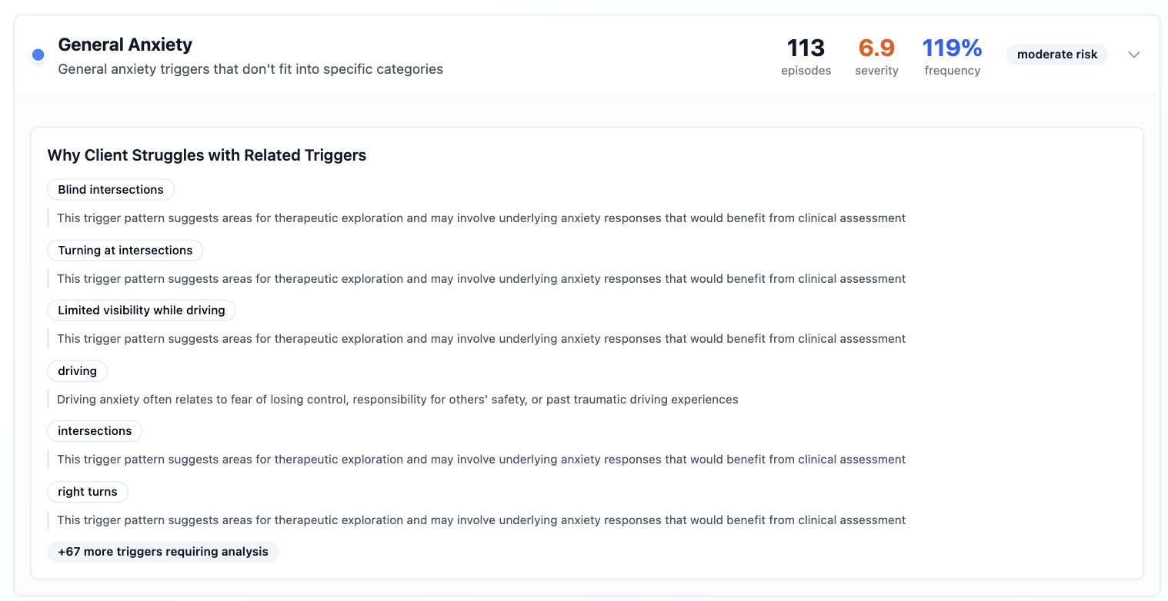

The patient in this case described that he was suffering with the fear of driving, which was categorized as General Anxiety, which should be categorized as more specific like “Drive of Fearing”. In this part Claude failed to make the proper categorization or in some part of the process in the code the data was not shown or passed correctly.

Add a configurable mapping for trigger phrases → categories (e.g., “fear of driving” → “Driving Anxiety”) so Claude or GPT doesn’t mis-label.

Also, instead of saying Blind Intersections and after that: “This trigger pattern suggests areas for therapeutic exploration and may involve underlying anxiety responses that would benefit from clinical assessment”.

It should something more like Patient’s “Drive of Fear” is attributed to fear crashing his car or causing the death of someone or tragedy while driving, patient’s anxiety increases :

* Blind intersections
* Turning at intersections
* Limited visibility while driving

**Track Outcomes/ Treatment tab**

* When clicking on the button “Connect with Therapist”, it should take you to the “Contact Therapist” tab which is not currently happening.
* In the part of Weekly Intervention Summaries, in the specific part of “Key Points This Week:” we see that the part display this:
  + “Recommended strategies: social skills training, exposure therapy, cognitive restructuring”
  + However, this should tell us why. It should be more like:
    - Recommended Strategies: “social skills training focus on talking with women or with people for first time”, “exposure therapy in driving, gradual exposure therapy (current basic exposure)”.
* Patient Nudges: Gentle reminders tied to incomplete milestones or skipped sessions; these should be notifications.

**Contact Therapist tab**

* If patient selects in “No, I don’t have a therapist”, when the person selects the button “Download My Anxiety Data” it should download the Download History and Download Conversation Summary reports

**Help Tab**

* Delete these two please **“**How do I track my anxiety over time?” and “How does therapist matching work?”

**Therapist - Patient**

**Initial Registration**

* If account has already been created it shouldn’t allow you to register again.
* When therapist finishes registering, it is being redirected to the Patient’s portal which is wrong. there is already a Mental Therapist Portal, it should redirect the therapist to this Mental Therapist Portal.
* After registering it takes 3-5 seconds to redirect to the Mental Therapist Portal; it should take him immediately to the Mental Therapist Portal.
  + Here currently after the therapist registers, the Mental Therapist Portal, it asks to put again the email of the therapist, which shouldn’t be the case because the therapist already has registered

**Mental Therapist Portal**

* In the therapist portal to locate a patient, the therapist needs to input both the email of the patient and the code of the patient. Currently is working with either one email or code, that shouldn’t be the case. The code is received by email when the patient requests to connect with his mental therapist.

* When the therapist puts both patient’s code and email, then we can see below the records found of the patient, here it’s providing the record found with the email of the patient, but it should also show the name of the patient.
* When the therapist selects on the patient’s record, he should see all that the patient is seeing in the analytics tabs plus the “Weekly Intervention Summaries” from the “Track Outcomes / Treatment” tab. Currently it’s just showing what it’s in the analytics tab, we need to add “Track Outcomes / Treatment” tab.
  + Let therapist correct mis-categorized triggers, which updates past entries for consistent reporting.
* The therapist should have also these new tabs (these hasn’t been created) the next tab is Chat tab, these should be a companion to the Therapist which should be also called Vannesa. Now given that the data is confidential, Claude can’t not know or have access to the patient’s data.
  + Thus, legally speaking we must find a way that when the therapists ask about a patient or based on patients’ data, Claude just understand this as someone’s X person rather than the actual patient. **THE SAME APPLIES WITH PATIENTS**
  + Remember that when the therapist asks about the specific patient, Vanessa should help him.
* The therapist should also have a new tab that say “Reports”, here the therapists should see the “Download History” and “Download Conversation Summary” of the patient, he can download them, however he should be able to see them.
* The last tab that needs to be created for the therapist is “Treatment Creation”
  + Here the Therapists creates a treatment with the patient based on goals or suggestions the therapists have with his/her conversation with the patients. This treatment and goals should be the also transposed to the current treatment of the Patient. Also, the Therapist should be able to change or adapt treatment or goals at any time of the patient, and that should be transposed/updated to the patients’ portal.
    - Here it’d be great if the therapist can record the interventions with patient so it can help with the creation of treatment’s plans, when the therapist is writing it after the visit, etc.
      * Also, it should allow the Therapist if he/she wants to send email to patient to write current treatment with goals, so Vanessa knows what exercises or types of activities needs to give to patient.
    - Also it’d be great if therapist can attach personal notes to goals if desired.
    - If Therapist already has patients, in the “Treatment Creation” he should be able to copy or paste from his personal notes about what he is currently doing in the treatment.
      * Also, it should allow the Therapist if he/she wants to send email to patient to write current treatment with goals, so Vanessa knows what exercises or types of activities needs to give to patient.
      * Remember that if Vanessa contacts Therapists to change goals, Therapists should first give the green light for patient to change goals based on what patient sees more convenient. Otherwise, that is not possible and sends back message to patients saying it’s not possible according to the therapist in a nice way.
* Therapist should receive notification if the patient interventions are not working or working correctly based on the analytics tabs that the Therapists sees from patients or the reports that are in the reports tab.
  + Thus, each week the AI agent should read the reports and analytics of the patients and notify the therapists avoid the patients as well as when the patient is a critical state.

**Overall Fixes / Tests**

* App should be able to work in English and Spanish; it currently works only in English.
* App should be working following HIPAA compliance regulations.
  + Even in MVP, enable Supabase RLS policies so:
    - Patients see only their own data.
    - Therapists see only linked patients.
  + Strip all PHI before sending anything to AI models, replacing names with“Patient X”.
* For patients without a therapist:
  + Show a clear “You’re in self-guided mode” banner.
  + Adjust Vanessa prompts so they don’t reference therapist interactions.
  + Ensure all downloads work without a linked therapist.
* App should have some form of cybersecurity given that a leaked of records could be a huge problem
* Test each bottom, option, and function of the app from the user patient and mental therapist perspective that is working.
  + For example, patients want to reset password or add age
* **Instead of loading full app then hiding tabs, load only relevant code for therapist or patient role.**
  + **This improves speed and avoids users seeing tabs they shouldn’t.**

Some Ideas for part of Testing could be BUT ARE NOT LIMITED TO:

**1. Make Test Data & Accounts Easy to Reset**

* Create a **Supabase seed script** that generates:
  + 2 therapists, 4 patients, linked/unlinked cases.
  + Sample anxiety logs, goals, triggers, outcomes.
* Add a simple “reset DB” function in staging so you can quickly re-test flows after fixes.

**2. Instrument Latency & Errors**

* Add lightweight **client-side performance logging**:
  + Measure API call times for login, assessment, chat.
  + Track avatar load times.
* Add **Sentry (or Supabase logs)** for JS errors so you don’t rely on testers reporting them.

**3. Simplify AI Integration for Early Testing**

* Make AI model configurable via .env:
  + Allow switching GPT-5 ↔ Opus without code changes.
  + Toggle “verbose” vs “concise” response modes in chat for A/B testing.
* Add a **chat response timeout fallback** — if AI doesn’t reply in X seconds, send a polite retry or simplified answer.

**4. Faster First-Run Experience**

* After registration, preload **next-step** assets (assessment/goals) in the background to kill the 3–5s waits.
* Cache therapist directory search results locally for faster revisit.

**10. Testing Shortcuts**

* Add **fake data injection buttons** in staging:
  + “Generate last week’s anxiety logs”
  + “Create 3 dummy goals”
  + Lets you see analytics/charts without waiting days for real data.